

Identity Manager
Web Development with Angular
- Video Series -

Herwig Abele | Global Enablement Lead IAM
One Identity - Technical Enablement

Table of Contents
Identity Manager Web Development with Angular - Video Series - 1
Prerequisites and Installation - 3
MS Windows Workstation 10 3
Linux Mint 20.3 5
Configure VM-Ware access comunicate with my host 5
Kernel > 4 5
Kernel < 4 5
Install Angular and development prerequisites 5
Install node.js and npm 5
Install Visual Studio Code 5
Install Postman 5
Install Git 6
Development 6
Create an Angular project 6
Create a development root if not exist 6
Protect development root using Git 6
Create a new project 6
Add and display some records 8
Format the list using Bootstrap 9
Implement a button to delete list entries 11
Implement input fields to create a new list entry 11
Create an account name out of Firstname and Lastname 13
Add REST based Web Service 13
Addendum 14
A1: Git log – Phase 2.1 14
A2: Code Listing Development Phase 2.1 14
A2.1: Index.html 14
A2.2: app/app-component.html 15
A.2.3: app/app.module.ts 16
A.2.4: app/identities.ts 17
A.2.5: app/app.component.ts 17

Prerequisites and Installation -

MS Windows Workstation 10
- Visual Studio Code (URL: https://code.visualstudio.com/ )
  - PS> choco install vscode -y
  - Add plugins
    - Angular Language Service
    - Angular Snippets
    - NX Console
    - HTML CSS Support
    - CSS formatter
- node.js (Angular) (URL: https://nodejs.org/en/ )
  - PS> choco install nodejs-lts -y
  - PS> npm -v
  - PS> npm install -g @angular/cli
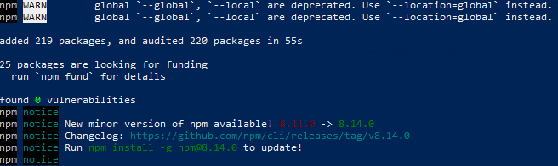P

PS> ng version
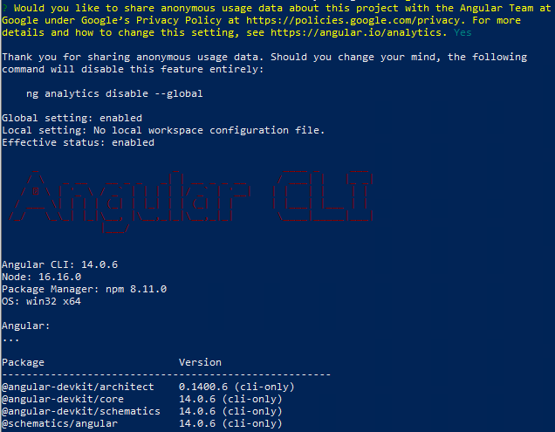

Warning: The current version of Node (17.9.0) is not supported by Angular.
- Git
- PS> choco install git -y
  - Configure your global username and Password
  - PS> git config --global user.name “Herwig Abele”
  - PS> git config --global user.email “herwig.abele@quest.com”
- Postman
  - PS> choco install postman -y

Linux Mint 20.3

Configure VM-Ware access comunicate with my host

Kernel > 4
mkdir /home/[username]/shares
/usr/bin/vmhgfs-fuse .host:/ /home/[username]/shares -o subtype=vmhgfs-fuse,allow_other
possible to activate allow other users in /etc/fuse.config

Kernel < 4
mkdir /home/[username]/shares
mount -t vmhgfs .host:/ /home/user1/shares

Install Angular and development prerequisites

Install node.js and npm
sudo apt update
sudo apt install curl build-essential -y
curl -sL https://deb.nodesource.com/setup_18.x | sudo -E bash -
sudo apt install nodejs -y
node --version
npm -v
sudo npm install -g @angular/cli
ng --versiony

Install Visual Studio Code
sudo apt update
sudo apt -y install wget
sudo apt update
sudo apt install apt-transport-https
curl https://packages.microsoft.com/keys/microsoft.asc | gpg --dearmor > microsoft.gpg
sudo install -o root -g root -m 644 microsoft.gpg /etc/apt/trusted.gpg.d/
sudo sh -c 'echo "deb [arch=amd64] https://packages.microsoft.com/repos/vscode stable main" > /etc/apt/sources.list.d/vscode.list'
cat /etc/apt/sources.list.d/vscode.list
deb [arch=amd64] https://packages.microsoft.com/repos/vscode stable main
sudo apt update
sudo apt install code

Install Postman
sudo rm /etc/apt/preferences.d/nosnap.pref
sudo apt update
sudo apt install snapd -y
sudo snap install postman

Install Git
sudo apt install git -y

Code Development

Create an Angular project

Create a development root if not exist
C:\> md %userprofile%\Documents\Angular-Dev
C:\> cd %userprofile%\Documents\Angular-Dev

Protect development root using Git
git init
Basic Git configuration
git config --local user.name 'Herwig Abele'
git config --local user.email 'Herwig.Abele@OneIdentity.com'
Windows (PowerShell) --> show available Git config:
dir -Force
Linux (Bash):
ls -al
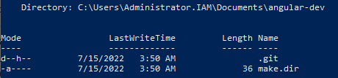

Note: This protects the whole Angular-Dev folder and all of its sub-folders (Angular projects). To protect just one single project a git init needs to happen after the project was created. Therefor the command prompt needs to be located in the project root.

Git:
1122248 Initial empty folder for Angular projects -> all protected by one Git repository
1 file changed, 1 insertion(+)

Create a new project
- Open Visual Studio code in %userprofile%\Documents\Angular-Dev
code .
- Create a new project
ng new identity-management
Note: We implemented no routing (working with menus) this can be implemented later. We also used the standard CSS style for a layout. This is recommended until you need nothing other else in addition.

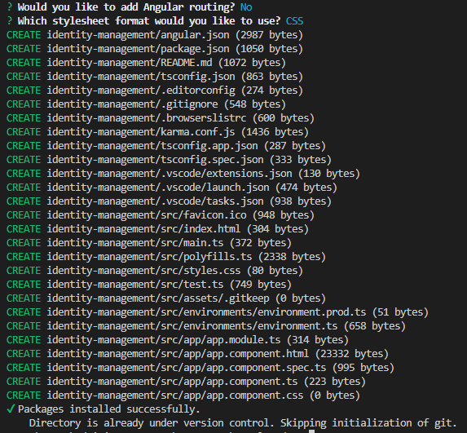
- Commit the empty project
git commit -m “New Angular project”
- Start the new empty Angular project
ng serve --open
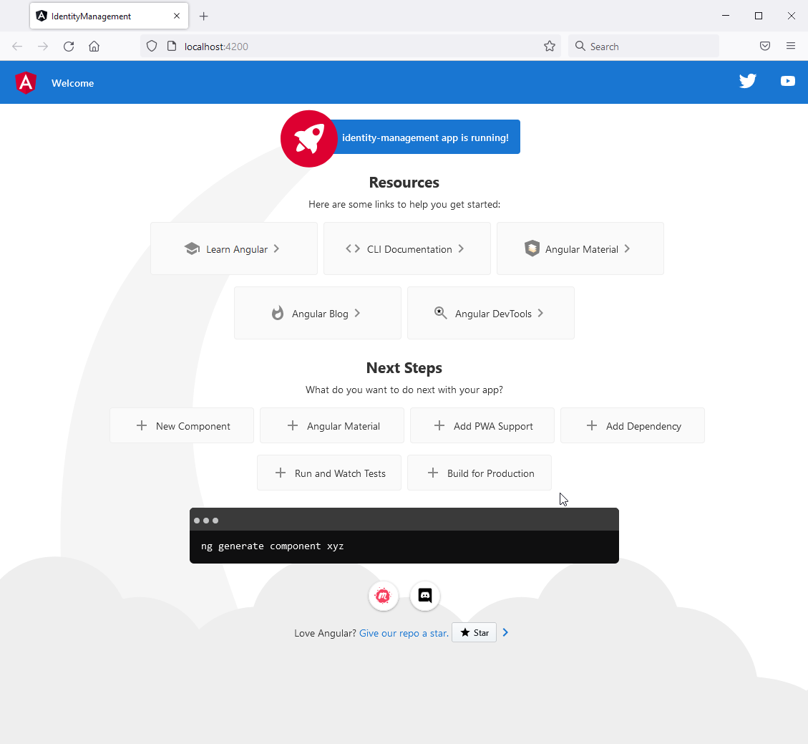

Git:
30b5e4a Empty Angular project IDENTITY-MANAGEMENT
28 files changed, 21959 insertions(+)

*** End of videos 1.1-3 ***

Add and display some records
- Delete all from file: app.component.html
- Have a look at the Angular HOT-RELOAD in the served browser window, saving files (recognize the Browser URL: “http://localhost:4200/”)
- Insert {{title}} and “Hello World” into the app.component.html
- Misspell the name {{title1}} and start the console Window in your Browser (Ctrl+Shift+J)
- Create a new file for a new data type called identities.ts to declare the data structure of an identity
Git:
9fde8ec (HEAD -> master) Create an interface for an identity - data structure we need
3 files changed, 20 insertions(+), 483 deletions(-)
- Link the new identities.ts in app.components.ts and create a sample data (Identity array → identities)
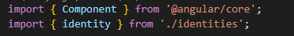
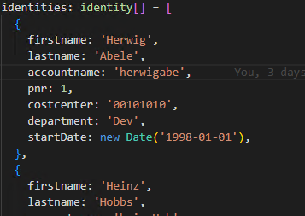
- Show parts of the entries in a Browser (app.components.html. If you try to show the whole array you will get [object Object] – warning outlining that the data is to complex for a simple output.
- In app.components.html define a *ngfor loop to show data properties.
Git:
09a8b01 Create and display identity sample data
4 files changed, 26 insertions(+), 1 deletion(-)

Format the list using Bootstrap
Note: In an Identity Manager – Standard web portal all layout is done using “Elemental UI” (by One Identity) based on a layout framework “Angular material” (by Google). We will show this detailed in later parts of our Angular Training.
For this, first baby steps we use another framework called “Bootstrap” which is another, less complex framework, every web-developer should have recognized.

- Integrate Bootstrap as a CSS layout:
https://getbootstrap.com/
- From Home page integrate link and script into the globale index.html. This makes Bootstrap available for all Angular apps in this Dev-space.
- Format the sample data using
  - Card: https://getbootstrap.com/docs/5.2/components/card/#about
  - Grid: https://getbootstrap.com/docs/5.2/layout/grid/#example
- Opportunities to display date values
Note: Trying to display the date values, it is an opportunity to show especially date values not set. This is a standard business behavior for unlimited employee contracts. To handle this problem (you will not see all entries, because displaying is broken for undefined values), some data changes are needed.
  - Format the date using a pipe format https://angular.io/api/common/DatePipe
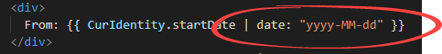
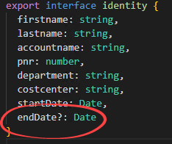
  - Change interface in identities.ts making the endDate property optional. In an interface the “?” can be used. This effects an interface as well (interfaces does have all properties mandatory).
Optional with “?” →

  - Removing all endDate=’’ values in the Data source (app.component.ts).
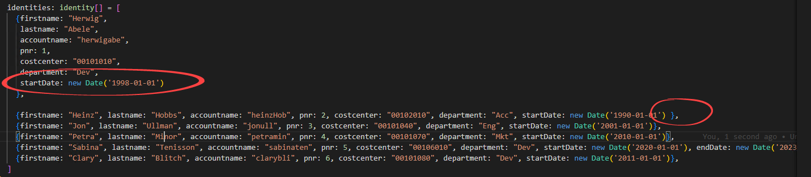
  - Formatting date values in app.component.html using the pipe formatter
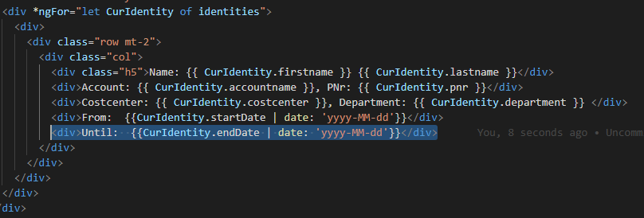
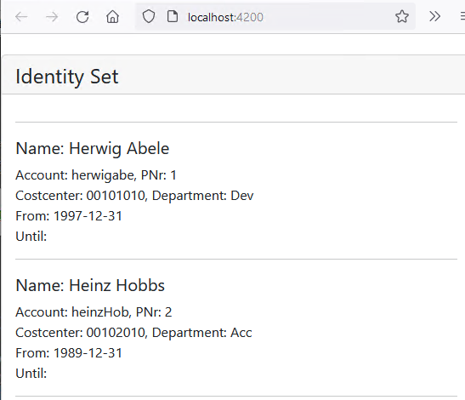 Something similar to this...
Git:
3b6e1f5 Integrating Bootstrap and formatting Date values
5 files changed, 28 insertions(+), 14 deletions(-)

Implement a button to delete list entries
- Define a button with a click – event in app.component.html
- In app.component.ts define a function to filter the current entry out of the collection
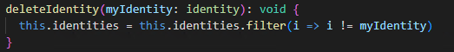
Git:
96474b5 Implement a button to delete single list entries of the sample data set
3 files changed, 14 insertions(+)

Implement input fields to create a new list entry
- Add FormModule (to work with forms) to app.module.ts
- Create a form in app.component.html
https://getbootstrap.com/docs/5.2/forms/overview/#overview
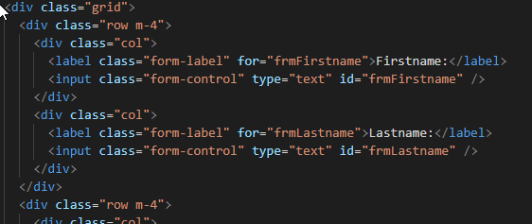
- Create a button to submit changes in app.component.html
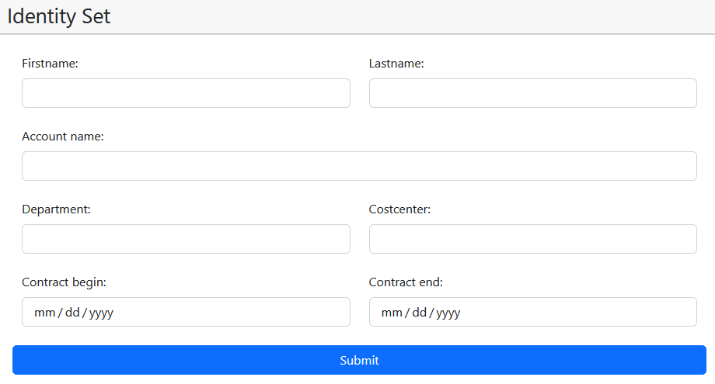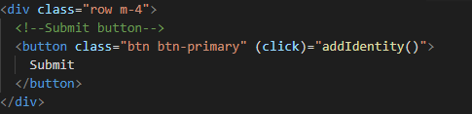
- Create a new function in app.component.ts to store data objects to be implemented below
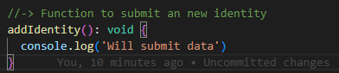
- Create a new data object in app.components.ts
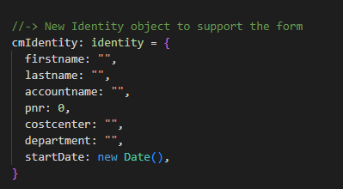
- Bind the data object to form in app.components.html
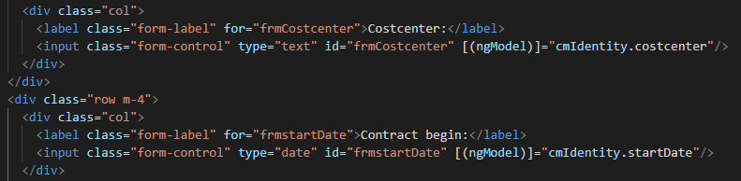
- In app.component.ts implement function to store data into data set
- Update cmidentity and addIdentity() in app.component.ts to create a new pnr as max of all pnr
https://stackoverflow.com/questions/4020796/finding-the-max-value-of-an-attribute-in-an-array-of-objects
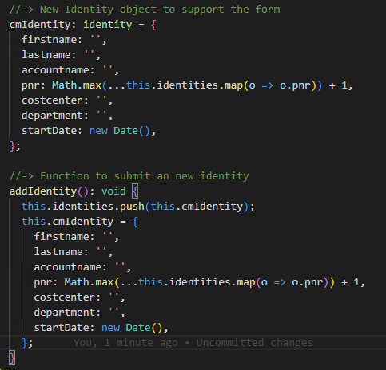
Git:
9b97a0 Form to insert new identity records implemented
4 files changed, 176 insertions(+), 34 deletions(-)

Create an account name out of Firstname and Lastname
Note: This is an exercise similar to an Identity Manager data template. The functions needs to build the account name from firstname + first 3 char of a lastname . This is a change happens to the cmIdentity object account name.
- Create a new function in app.component.ts
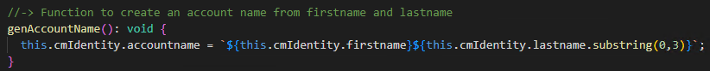
- Call the function by changes in firstname, lastname in app.component.html
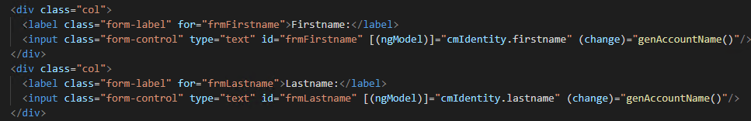
Git:
a200ff4 Template to account name creation (from first and lastname) added
3 files changed, 9 insertions(+), 3 deletions(-)

*** End of videos 2.1-x ***

Add a REST based Web Service

Note: This is the end of all Angular code development we show in the official “Identity Manager - Angular Web Development” video series (on YouTube):
The purpose of this lectures was to show how Angular as a development Framework works by sample. This is of course not sufficient enough to learn, how to work with Angular. Therefore at least an Angular course and some experience is needed before a new developer could/should try to understand and to modify the heavily more complex One Identity – Identity Manager – Standard Web Application, Angular based.
Nevertheless, in the following steps we will add more functionality to this small exercise which lives only in this zipped git project. This means, students can try to follow the steps using the One Identity - Technical Enablement Git repository from Github which will be continuously extend after the video course from time to time. This will show some more native TypeScript and Angular techniques.

Further TypeScript / Angular code development

Separate listing and creation of identities using components
Note: To handle all functionality in just one application/module is not common. It was helpful to lower the complexity during the first steps but now we like to:
- Separate listing and creation of identities using components.
- Insert routing and a menu.
- Allow changing of available identity records.

- Create a new component identityList
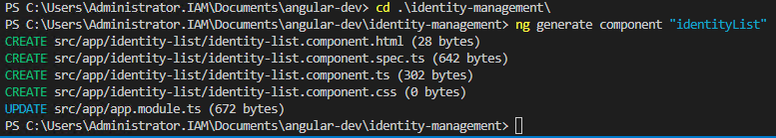
- Move display of records from app.component.html to identity-list.component.html

- Create a new mock-identities.ts document in folder app.
  - Import the identity object into mock-identities.ts
  - Move the Identity array from app.components.ts to mock-identities.ts
  - Extend the array by exporting it as a data object (const)
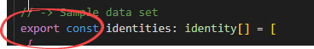
- Import identities in identity-list.component.ts
- create an object “MyIdentities” and assign the imported identities.
- Move function used to delete records to identity-list.component.ts. You might need to change “identities” in the function references to “MyIdentities”. The “MyI” is helpful to separate the local variable from the imported data object.
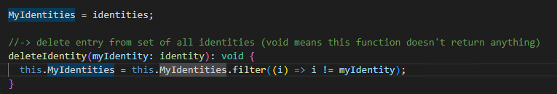
- Create a new component cmIdentity. This is for creating and modifying of an identity object.
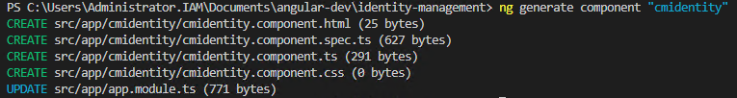
- Into the new cmidentity.component.ts
  - Import identity from identities
  - Import identities from mock-identities
  - Create a “MyIdentities” variable and assign identities.
  - Copy all content from app.component.ts which is related to adding an identity record (cmidentity..., GetIdentity()..., GenAccountName()…)
  - Replace references to “identities” by “MyIdentities”
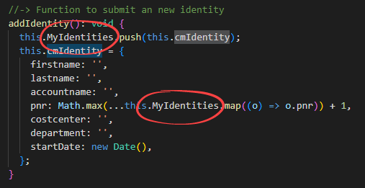
- From app.component.html copy the complete form section into the cmidentity.component.html
- Reference the new selector “app-cmidentity” as a new a root selector in app.component.html
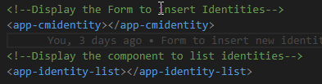
- After solving all errors you should see exactly the picture you started with!

Note: Of course this was a lot of work taking no visible effect. In this part of the lecture we separated the single application in different components and we moved the mock-data to a separate file we are able to include in these components. This was a big step into the direction of big applications.

Git:
eb365f7 Separated the application from listing and creating objects. Separation of moc-data.
13 files changed, 287 insertions(+), 187 deletions(-)

Insert routing and a menu and more Layout
- Add a flat routing module to the application. --Flat adds a “.ts” file directly in the root of the application. The flag --module=app inserts the new module directly into the app.module.ts
- In app-routing.module.ts
  - delete the CommonModule reference – not needed.
  - Import and initiate RouterModule
  - Import Routs
  - Import IdentityListComponent
- In app-routing.module.ts insert a new Routes array object
  - Add one route with path and related component
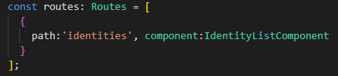
  - Initiate the RouterModule (imports) – (use forRoot for a menu in the app root)
  - Make the RouterModule available (export)
  - Delete the declarations (not needed)
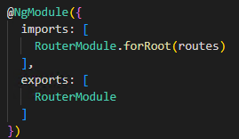
- In app.component.html replace the app-cmidentity and pp-identity-list component tags by on single router-outlet tag.
- To see a preview you need to use URL: http://localhost:4200/identities
- To allow http://localhost:4200 to redirect to URL: http://localhost:4200/identities (default start page) add a redirector in app-routing.module.ts (another extra routes entry.
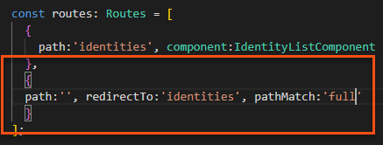
- In app.component.html insert from bootstrap, parts of the “Jumbotron” template
https://getbootstrap.com/docs/5.2/examples/jumbotron/
  - Ensure the app header is displayed
  - Ensure the router is included into the outer div.
  - Add m-4 to the title
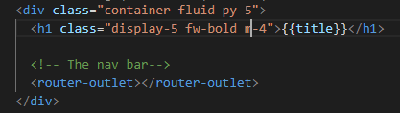
- In identity-list.component.ts enter a variable for a subtitle
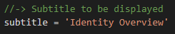
- In identity-list.component.html
  - Change the card class mt-4 to m-4 (this displays a border around the whole module)
  - Change the header using the new defined subtitle variable
  - Move the horizontal ruler downward to ensure it gets displayed after each entry
  - Add a card footer
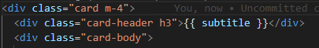
…
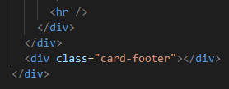

- In cmidentity.component.ts enter a variable for a subtitle
- In identity-list.component.html
  - Enter div with class card and a header similar to list-identity.component.ts
  - Change the header using the new defined subtitle variable
  - Change the div containing the submit button to a footer
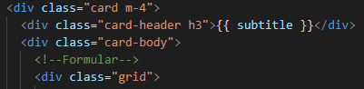
…
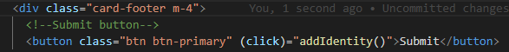
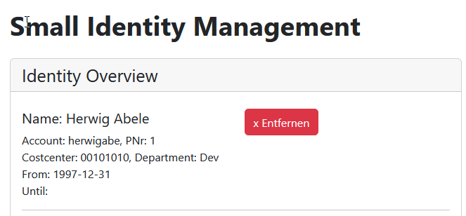

Git:
7041d60 Insert routing and a menu and more Layout
8 files changed, 133 insertions(+), 58 deletions(-)

Add navbar to visualize the menu
- Minor correction: In identity-list.component.html change button name to “Remove” (old bug to be solved).
- Open the Bootstrap documentation and search for navbar
https://getbootstrap.com/docs/5.2/components/navbar/#how-it-works
- Copy code for a navbar you like into app.component.html (above all other code)
- In app.component.html
  - Delete components you don’t need (all beside two standard menu entries)
  - Add “m-4” to the top class
  - Rename “navbar” to something like “I-Mgmt”
  - Configure navbar href to {{appLink}}
  - Rename first navigation entry to “Overview” and the second navmenu to “Modify”
  - Replace Overview href with routerLink="/identities"
  - Replace Modify href with routerLink="/modify"
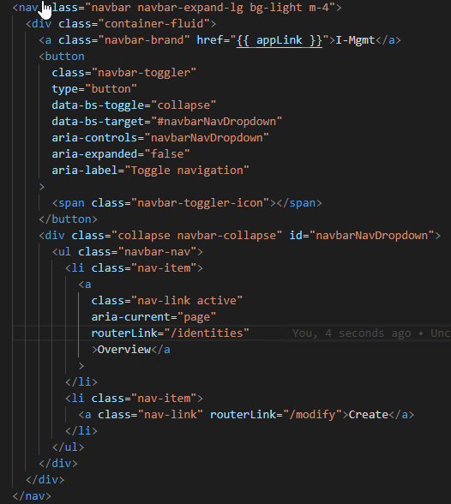
- In app.component.ts add a variable appLink="http://localhost:4200"
- In app-routing.module.ts add an entry for modify page
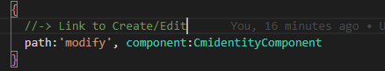
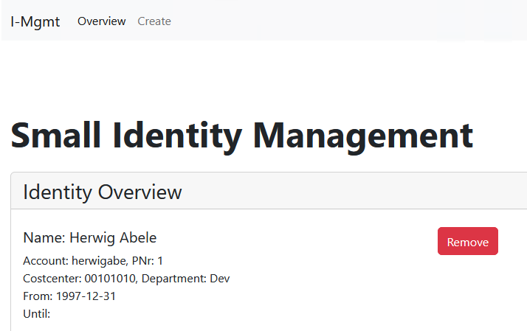
Git:
2fd4c25 Add navbar to visualize the menu
5 files changed, 47 insertions(+), 10 deletions(-)

Allow modifying of available identity records
- In app-routing.modules.ts
- Rename the route path “modify” to “create”
- Add a new route “modify” allowing a rout parameter “/:pnr” (to edit a record we need to identify the record by a unique identifier which is our personnel number. As component we use the same component as for creating a record (form))
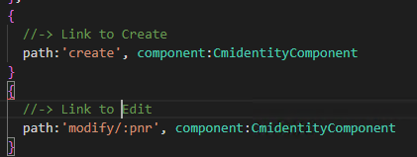
- In app.component.html replace the “modify” path in the “create” menu with path “create”
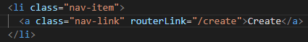
- In identity-list.component.html
  - Find the div tag wraps firstname and lastname and switches “div” to “a”. The a tag makes it clickable.
  - Add a routerLink for modify and parameter pnr and use an interpolation binding to assign the current selected personnel number {{CurIdentity.pnr}}
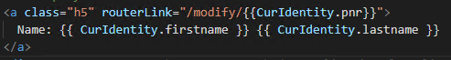
- To load the right record into the form add to cmidentity.component.ts
  - Import for Router and ActivatedRoute
  - Initiate these in the constructor. This time we will use “private” because its only used in this module.
  - Add to ngOnInit() a variable “pnr” getting parameter pnr from the activated route. Ensure the returned value is a number.
  - Add another variable get the record with this pnr. Add a “Non-null assertion operator “ => ! to ensure the value can’t be null.
  - Assign this record to cmIdentity
  - Ensure that all of this only happens for edited records and not for created
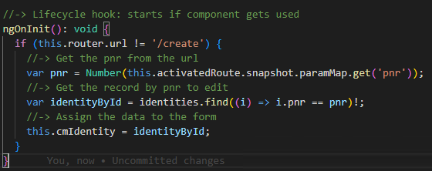
  - Ensure the Form jumps back to the overview list after the created / changed object is submitted
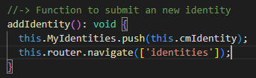
- To solve the problem with the non displayed date values (for both date values), establish a one way data binding modify file cmidentity.component.html:
  - Replace the two way data binding by a [value] handler
  - Add a pipe format for an iso date to the date value “|date:’yyyy-MM-dd’”
  - Add an event (input) to each date input and name the function “dateChanged($event)
  - $event offers the event called, but you need as well a parameter which identifies the date field (startDate // endDate). Therefor, we use a boolean flag which is true for the startDate.
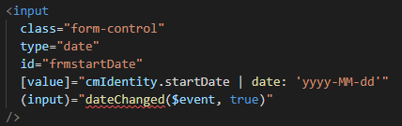
- Define the new function in cmidentity.component.ts
  - We need to get the value out of the touched HTML control
  - We need to store the right date value depending on the flag we inserted
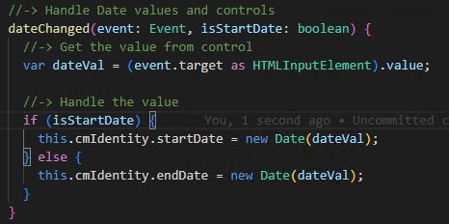
- To ensure we don’t create everytime a new object, if we modify an object wenn need to separate a create from an edit submit. In cmIdentity.component.ts:
  - Find function addIdentity()
  - From ngOnInit copy the line where the variable identityById gets created
  - Modified the copied line by assigning “this.cmIdentity.pnr” as the current object value
  - Remove the “!”, we need null values if they happen
  - For null or undefined lets push a new element and for all others just store the available one.
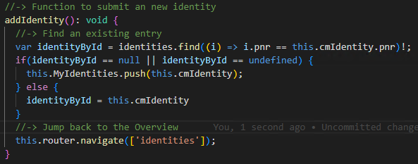
Git:
8dc6fc7 Allow modifying of available identity records
7 files changed, 51 insertions(+), 28 deletions(-)

Addendum

A1: Git log – Phase 2.1
Git:
a200ff4 Template to account name creation (from first and lastname) added
3 files changed, 9 insertions(+), 3 deletions(-)

29b97a0 Form to insert new identity records implemented
4 files changed, 176 insertions(+), 34 deletions(-)

96474b5 Implement a button to delete single list entries of the sample data set
3 files changed, 14 insertions(+)

3b6e1f5 Integrating Bootstrap and formating Date values
5 files changed, 28 insertions(+), 14 deletions(-)

09a8b01 Create and display identity sample data
4 files changed, 26 insertions(+), 1 deletion(-)

9fde8ec Create an interface for an identity - data structure we need
3 files changed, 20 insertions(+), 483 deletions(-)

30b5e4a Empty Angular project IDENTITY-MANAGEMENT
28 files changed, 21959 insertions(+)

1122248 Initial empty folder for Angular projects -> all protected by one Git repository
1 file changed, 1 insertion(+)

A2: Code Listing Development Phase 2.1

A2.1: Index.html
<!doctype html>
<html lang="en">
<head>
<meta charset="utf-8">
<title>IdentityManagement</title>
<base href="/">
<meta name="viewport" content="width=device-width, initial-scale=1">
<link rel="icon" type="image/x-icon" href="favicon.ico">
<!-- Bootstrap Integration Part 1 -->
<link href="https://cdn.jsdelivr.net/npm/bootstrap@5.2.0-beta1/dist/css/bootstrap.min.css" rel="stylesheet" integrity="sha384-0evHe/X+R7YkIZDRvuzKMRqM+OrBnVFBL6DOitfPri4tjfHxaWutUpFmBp4vmVor" crossorigin="anonymous">

</head>
<body>
<!-- Bootstrap Integration Part 2 -->
<script src="https://cdn.jsdelivr.net/npm/bootstrap@5.2.0-beta1/dist/js/bootstrap.bundle.min.js" integrity="sha384-pprn3073KE6tl6bjs2QrFaJGz5/SUsLqktiwsUTF55Jfv3qYSDhgCecCxMW52nD2" crossorigin="anonymous"></script>
<app-root></app-root>
</body>
</html>

A2.2: app/app-component.html
<div class="card mt-4">
<div class="card-header h3">Insert Identity </div>
</div>
<div>
<!--Formular-->
<div class="grid">
<div class="row m-4">
<div class="col">
<label class="form-label" for="frmFirstname">Firstname:</label>
<input class="form-control" type="text" id="frmFirstname" [(ngModel)]="cmIdentity.firstname" (change)="genAccountName()"/>
</div>
<div class="col">
<label class="form-label" for="frmLastname">Lastname:</label>
<input class="form-control" type="text" id="frmLastname" [(ngModel)]="cmIdentity.lastname" (change)="genAccountName()"/>
</div>
</div>
<div class="row m-4">
<div class="col">
<label class="form-label" for="frmpnr">Personnel number:</label>
<input class="form-control" type="number" id="frmpnr" [(ngModel)]="cmIdentity.pnr"/>
</div>
<div class="col">
<label class="form-label" for="frmAccountname">Account name:</label>
<input class="form-control" type="text" id="frmAccountname" [(ngModel)]="cmIdentity.accountname"/>
</div>
</div>
<div class="row m-4">
<div class="col">
<label class="form-label" for="frmDepartment">Department:</label>
<input class="form-control" type="text" id="frmDepartment" [(ngModel)]="cmIdentity.department"/>
</div>
<div class="col">
<label class="form-label" for="frmCostcenter">Costcenter:</label>
<input class="form-control" type="text" id="frmCostcenter" [(ngModel)]="cmIdentity.costcenter"/>
</div>
</div>
<div class="row m-4">
<div class="col">
<label class="form-label" for="frmstartDate">Contract begin:</label>
<input class="form-control" type="date" id="frmstartDate" [(ngModel)]="cmIdentity.startDate"/>
</div>
<div class="col">
<label class="form-label" for="frmendDate">Contract end:</label>
<input class="form-control" type="date" id="frmendDate" [(ngModel)]="cmIdentity.endDate"/>
</div>
</div>
<div class="row m-4">
<!--Submit button-->
<button class="btn btn-primary" (click)="addIdentity()">
Submit
</button>
</div>

<div class="card mt-4">
<div class="card-header h3">Identity Set</div>
<div class="card-body">
<!--Loop to step through all entries of the data array-->
<div *ngFor="let CurIdentity of identities">
<hr />
<div>
<div class="row mt-2">
<div class="col">
<!--Display values-->
<div class="h5">
Name: {{ CurIdentity.firstname }} {{ CurIdentity.lastname }}
</div>
<div>
Account: {{ CurIdentity.accountname }}, PNr:
{{ CurIdentity.pnr }}
</div>
<div>
Costcenter: {{ CurIdentity.costcenter }}, Department:
{{ CurIdentity.department }}
</div>
<div>
From: {{ CurIdentity.startDate | date: "yyyy-MM-dd" }}
</div>
<div>Until: {{ CurIdentity.endDate | date: "yyyy-MM-dd" }}</div>
</div>
<div class="col">
<!--Button to delete list entries-->
<button
class="btn btn-danger btn-sn"
(click)="deleteIdentity(CurIdentity)"
>
x Entfernen
</button>
</div>
</div>
</div>
</div>
</div>
</div>
</div>
</div>

A.2.3: app/app.module.ts
//-> needed to use the 2 way data binding
import { NgModule } from '@angular/core';
//-> oob to render the content
import { BrowserModule } from '@angular/platform-browser';
import { AppComponent } from './app.component';
//-> Needed to work with forms
import { FormsModule } from '@angular/forms';

@NgModule({
declarations: [
AppComponent
],
imports: [
//-> Some imports needs to be preloaded to become usable
BrowserModule,
FormsModule,
],
providers: [],
bootstrap: [AppComponent]
})
export class AppModule { }

A.2.4: app/identities.ts
import { DecimalPipe } from "@angular/common";

// -> Data structure for a single identity
// -> created as an interface to get values required

export interface identity {
firstname: string,
lastname: string,
accountname: string,
pnr: number,
department: string,
costcenter: string,
startDate: Date,
endDate?: Date
}

A.2.5: app/app.component.ts
import { Component } from '@angular/core';
import { identity } from './identities';

@Component({
selector: 'app-root',
templateUrl: './app.component.html',
styleUrls: ['./app.component.css'],
})

// -> AppCompontent feature set
export class AppComponent {
title = 'Small Identity Management';

// -> Sample data set
identities: identity[] = [
{
firstname: 'Herwig',
lastname: 'Abele',
accountname: 'herwigabe',
pnr: 1,
costcenter: '00101010',
department: 'Dev',
startDate: new Date('1998-01-01'),
},
{
firstname: 'Heinz',
lastname: 'Hobbs',
accountname: 'heinzHob',
pnr: 2,
costcenter: '00102010',
department: 'Acc',
startDate: new Date('1990-01-01'),
},
{
firstname: 'Jon',
lastname: 'Ullman',
accountname: 'jonull',
pnr: 3,
costcenter: '00101040',
department: 'Eng',
startDate: new Date('2001-01-01'),
},
{
firstname: 'Petra',
lastname: 'Minor',
accountname: 'petramin',
pnr: 4,
costcenter: '00101070',
department: 'Mkt',
startDate: new Date('2010-01-01'),
},
{
firstname: 'Sabina',
lastname: 'Tenisson',
accountname: 'sabinaten',
pnr: 5,
costcenter: '00106010',
department: 'Dev',
startDate: new Date('2020-01-01'),
endDate: new Date('2023-05-01'),
},
{
firstname: 'Clary',
lastname: 'Blitch',
accountname: 'clarybli',
pnr: 6,
costcenter: '00101080',
department: 'Dev',
startDate: new Date('2011-01-01'),
},
];

//-> delete entry from set of all identities (void means this function doesn't return anything)
deleteIdentity(myIdentity: identity): void {
this.identities = this.identities.filter((i) => i != myIdentity);
}

//-> New Identity object to support the form
cmIdentity: identity = {
firstname: '',
lastname: '',
accountname: '',
pnr: Math.max(...this.identities.map(o => o.pnr)) + 1,
costcenter: '',
department: '',
startDate: new Date(),
};

//-> Function to submit an new identity
addIdentity(): void {
this.identities.push(this.cmIdentity);
this.cmIdentity = {
firstname: '',
lastname: '',
accountname: '',
pnr: Math.max(...this.identities.map(o => o.pnr)) + 1,
costcenter: '',
department: '',
startDate: new Date(),
};
}

//-> Function to create an account name from firstname and lastname
genAccountName(): void {
this.cmIdentity.accountname = `${this.cmIdentity.firstname}${this.cmIdentity.lastname.substring(0,3)}`;
}
}

- In NX select the Workspace
- Integrate Bootstrap
https://getbootstrap.com/docs/5.1/getting-started/introduction/
git log --oneline --shortstat

